In class question (Feb 7th, 2013)

The parameters of the circuit below are 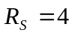k, 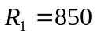k, 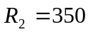k, and 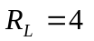k. The transistor parameters are 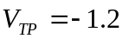V, 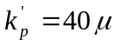A/V, 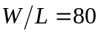, and 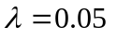V. (a) Determine 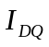 and 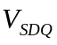. (b) Find the small-signal voltage gain 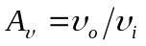. (c) Determine the small-signal circuit transconductance gain 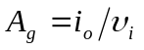. (d) Find the small-signal output resistance 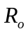.

Solution: The key is to identify it as a PMOS common drain amplifier. Then you can use the expressions for the small signal voltage gain and the output resistance
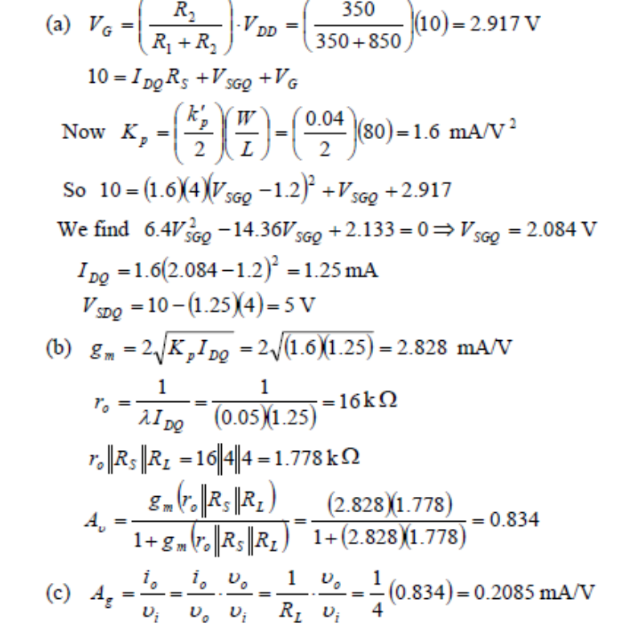
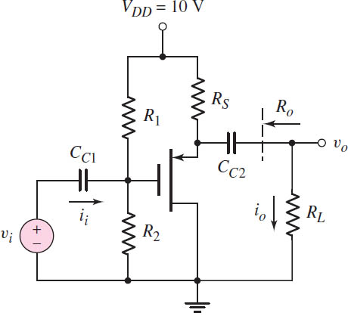
Inst

